Colorectal Cancer
Why do we need a screening test?
Colorectal cancer is the third most common cancer in our country and is regarded as a “silent” disease. Due to its being normally asymptomatic and is usually detected after metastasis, only 50% of the patients can be cured. In fact, most Colorectal cancers are developed from colorectal polyps during a period of 5~10 years. Therefore, canceration can be prevented if the polyps are detected and removed early. The possibility of being cured is normally raised to 80% or even better if it can be detected and treated in early stages.
What are the risk factors of colorectal cancer?
According to statistical analysis, there are 20 men and 16 women who may have Colorectal Cancer out of every one hundred thousand people. The risk rises 2~5 times if there is a family history of colorectal cancer or polyposis. Furthermore, patients who have inflammatory bowel disease, such as ulcerative colitis or Crohn's disease are more susceptible to colorectal cancer. Although some reports indicate that other dietary customs and life styles can increase the rate, there is no conclusion yet.
What screening tests should we have?
The easiest screening test for colorectal cancer, in addition to a rectal examination, is called the Occult Blood test. Stool Examination which can detect trace and not noticeable blood in the stool. The test is extremely simple and fast; however, it can only detect colorectal cancer and/or polyposis bleeding. Only 50% of colorectal cancer and 10% of polyposis patients have significant bloody stool sample to show positive reaction in this test. Furthermore, the test easily results in a false positive by the influence of food. As a result, it has to be performed along with other screening tests.
Colonoscopy is a test which uses a soft fiberscope allowing doctors to directly examine the internal condition of the lumen of colorectum. When a polyp or colorectal cancer is detected using the colonoscopy, we can immediately resect the polyps for biopsy or for further laboratory testing. Most colonoscopy exams can be arranged to be completed in the outpatient department; however, the patient may feel uncomfortable and inconvenient.
The Barium Enema examination, mainly used for detecting larger tumors, is unable to detect the smaller lesions accurately. Furthermore, residual stools may also affect the interpretation of the results.
When or at what age should the tests be taken?
For the asymptomatic, low risk group, it is suggested the Rectal Examination and Stool Occult Blood to be taken every year for age older than 40. For people older than 50, it is recommended a Colonoscopy or a Barium Enema Examination to be taken once every 5 years.
The following high risk groups have to be monitored and followed up.
- Patients, who have had any resected polyps of pre-malignant form, should take a Colonoscopy every year within the first three years after polyp detection. The Barium Enema Examination is another choice; however, resection of polyps cannot be accomplished during the procedure.
- Patients, whose close relatives such as brothers, sisters or parents have had colorectal cancer or polyps of pre-malignant form, should start to take a Colonoscopy or a Barium Enema Examination once every 5 years before the age of 40 or 5 years earlier than the age of diagnosis of colorectal cancer for the youngest family member.
- Patients with familial adenomatous polyposis (FAP) should have a genetic examination to determine if they are the gene carrier of this disease. The patient, carrying this kind of gene or being tested with inconclusive results, should take a Colonoscopy every year after adolescence to determine if phenotype of the gene has already shown. If Polyposis exists, the patient needs to discuss with the doctors whether a total proctocolectomy is necessary. Generally, this operation removes the whole colon and rectum.
- Patients with a personal history of colorectal cancer should undergo an examination of the whole colon within one year after the cancer is detected or removed, and then should be followed up every 3 years if the results show normal. The examinations include the Colonoscopy, the Barium Enema Examination along with the Rectal Examination and the Stool Occult Blood.
- Every 1~2 years, patients with inflammatory bowel disease (IBD) should undergo a Colonoscopy during the first 8 year period of time following the episode.
- Women with a history of breast cancer or cancers of the reproductive organs (ovary or uterus) have a 15% incidence rate of colorectal cancer. Consequently, she needs to take a Colonoscopy exam every 5 years after the age of 40.

Specialist and Clinic Time

Director, Shu-Wen Jao (code 20021)
Neihu Main Facility Tue 14:00-17:00
Thu 14:00-17:00
Tingjhou Branch Mon 09:00-12:00
Wed 14:00-17:00
Dr. Chun-Che Feng (code 20323)
Neihu Main Facility Fri 14:00-17:00

Dr. Chang-Chieh Wu (code 20276)
Neihu Main Facility Mon 14:00-17:00
Thu 09:00-12:00
Tingjhou Branch Tue 09:00-12:00
Dr. Cheng-Wen Hsiao (code 20325)
Neihu Main Facility Wen 09:00-12:00
Wen 18:00-21:00
Tingjhou Branch Thu 14:00-17:00
Address:
Neihu Main Facility: No. 325, Section 2, Chenggong Rd.,Neihu District,Taipei City 114, Taiwan
Tingjhou Branch: No. 40, Section 3, Tingjhou Rd.,jhongjheng District,Taipei City 100, Taiwan
Appointment line:
Appointment line by voice system
（02）87927111
Appointment line by jointers
（02）87927222
On- line registration website:
http://www.tsgh.ndmctsgh.edu.tw/
Colorectal Surgery
Colorectal Cancer

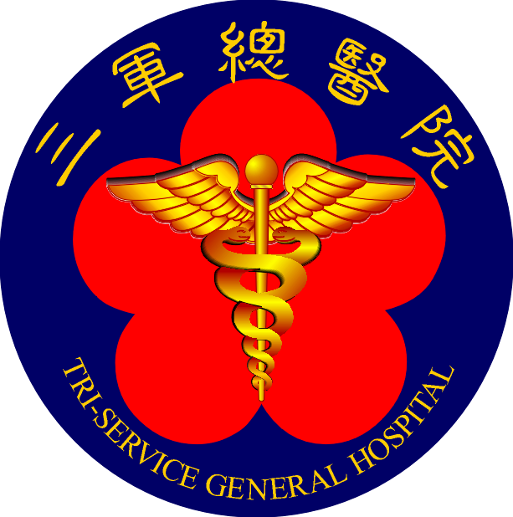

Healthy Colon, Happy Life
We care & You trust
Tri-Service General Hospital

Approved by Medical Records Committee in October 2007
Copyright © 2007 Tri-Service General Hospital.
All rights reserved.

