椎間盤突出病人手術前後護理指導(英文)
Preoperative and Postoperative Nursing Guidance for Patients with Herniated Intervertebral Disc

手術前(Before the surgery)
  - 醫師解釋病情之後，請簽妥「手術說明同意書」及「麻醉說明同意書」，並讓護理師檢查是否完整。
After the physician explained your illness, please properly sign the “Surgery Consent Form” and “Anesthesia Consent Form”, being checked for completeness by the nurse.
  - 護理人員會告知禁食時間，禁食期間包括不能喝水及任何食物。
Nursing staff will inform you of fasting schedule, both water-drinking and having any food are prohibited during the fasting period.
  - 練習深呼吸及咳嗽，以預防手術後肺部感染的合併症。
Practice deep breathing and coughing to avoid any complication resulted from postoperative pulmonary infection.
  - 手術當天，請務必取下身上飾品，包括：假牙、手錶、手環、項鍊等，需去除口紅及指甲油。換上手術衣（穿著方式如下圖），內衣褲均要脫掉，當通知要送手術室時，請先解小便或將尿袋排空。
At the same day of the operation, please be sure to remove accessories from your body including: removable denture, watch, bracelet, and necklace, etc., removing also lipstick and nail polish. Change your gown (wearing as shown in the figures below) while taking off underwear, please get to the toilet for urination or empty the urine collection bag upon being informed to be sent into the operation room.
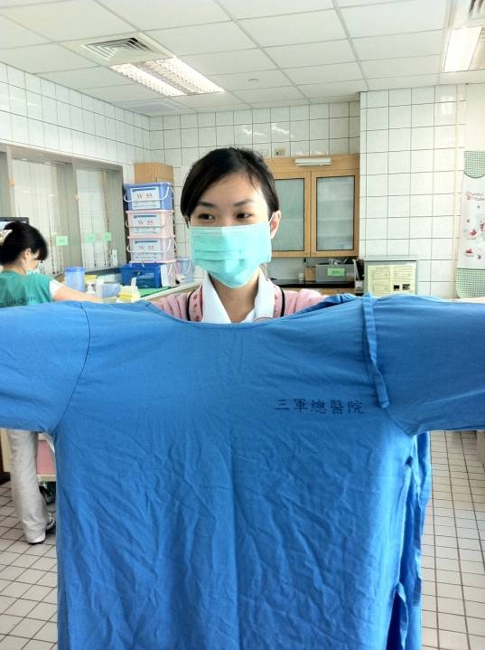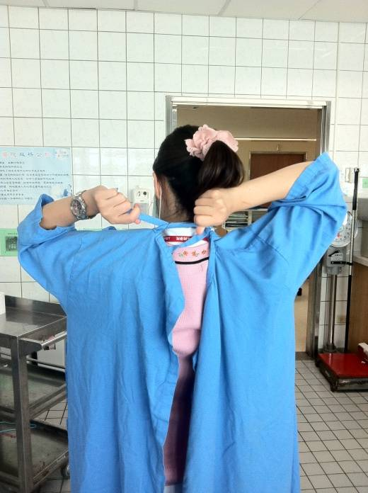
衣領朝前、綁帶朝後
Collar forward Binding cords backward

  - 若為頸椎手術會準備頸圈作為手術後支撐之用，並將頸圈一併帶入手術室。
For a cervical vertebra surgery, a neck lock will be prepared for postoperative spinal support, neck lock is to be carried along into the operation room.

手術後(After the surgery)
  - 頸椎手術(Cervical Vertebra Surgery)
- 進食：
(1)頸椎前位手術後可能發生暫時性喉嚨痛或吞嚥困難的現象，建議手術後6小時至術後3天內先進食冷流質的食物﹙如牛奶、豆漿、米漿﹚。正常飲食後，則以含有高蛋白、易咀嚼的食物為主。
After anterior cervical surgery, sore throat or dysphagia may temporarily occur, it is recommended to first have some cold and liquid foods (e. g. milk, soy milk or peanut milk) between 6 hours and 3 days after the operation. After the diet becoming normal, primarily have foods with high protein and easily chewable.
(2)頸椎後位手術者則進食不受限制。
There will be no diet restrictions for patients underwent posterior cervical surgery.
- 頸椎前位手術後，護理站或病房內會放置氣切包，以備緊急之用。若感覺有呼吸困難不適的情形，應立即通知醫護人員。
After anterior cervical surgery, a tracheostomy kit will be placed in nurse station or the ward for emergency use. In case of any dyspnea or discomfort, immediately inform medical staff.
- 休息及活動：術後應持續配戴頸圈，臥床時可採平躺及側臥姿勢，床頭可稍微搖高。下床時採漸進方式，下床活動前需再次確認頸圈穿戴妥當，再側身坐起。首先坐於床沿，若頭不暈即可下床活動，出院後頸圈需持續配戴數個月，配戴時間則依病情恢復情形決定。
Rest and activity: The neck lock should be continuously worn, lying in a supine position or lying on the side may be applied with slightly higher bedhead. Gradual movement is recommended when getting out of the bed, it is required to reconfirm properly wearing the neck lock before getting out of the bed for any activity, then sitting up sideways. First sit on edge of the bed, getting out of the bed for activities after no feeling of dizziness; the neck lock should be continuously worn for several months after discharge, wearing duration depending on recovery status of the illness.
  - 腰椎手術(Lumbar vertebra surgery)
- 進食：手術後6小時若無嘔吐情形即可進食，先喝水，無嗆咳情形後再以易消化的食物為主，如稀飯、米湯，如無腹脹、噁心等不適之現象，再換以高蛋白飲食為主，勿食活血的雞精、參湯或中藥等，可能會造成傷口出血。
Diet: In case of no any vomiting, having meals would be allowed 6 hours after the operation, starting first with water-drinking, then primarily having easily-digested foods such as congee and rice soup after no any chocking occurred, and shifting to primarily having food with high protein after no any discomfort such as abdominal distention or nausea occurred, do not have foods that stimulate blood circulation such as chicken essence, ginseng soup or herbal medicines to avoid wound bleeding.
- 翻身：護理師會教您圓滾木翻身﹙詳見護理指導NS-05﹚，至少每2小時更換姿勢，避免壓迫傷口，平臥時可在膝下放置枕頭，減輕脊椎壓力。
Turn-over: Nurses will instruct you in performing turnover with logroll (refer to Nursing Guidance NS-05), changing postures at least every two hours to avoid compression to the wound, placing a pillow under the knees when lying in a supine position to reduce spinal pressure.
- 活動：手術後可儘早於床上行踩腳踏車或抬腿運動，以增強下肢肌力及避免神經粘黏。經醫師評估後，可依指示開始下床活動，護理師會教您穿著背架方式，起床前先於床上穿著好背架，調整固定好後，以側躺方式，用手支托床墊坐起。採漸進式方法下床活動，先雙腳下垂，坐於床緣約15分鐘，若無頭暈現象，即可下床活動，但須有人陪伴在旁，避免發生跌倒事件。下床後，主要運動型式以散步為主，並依醫師指示穿戴背架3~6個月。
Activities: After operation, do cycling-like or leg-lift exercises on the bed as soon as possible to enhance muscular strength of lower limbs and avoid any nerve adhesion. After physician’s assessment, may start to get out of the bed for activities as per instructions, nurses will instruct you in the approach to wear the back pad, first lie in a supine position before get out of the bed, putting on the back pad with proper adjustment and fixing, sitting up by propping the bed up with hands sideways. Gradual movement is recommended when getting out of the bed for activities, first sit on edge of the bed for roughly 15 minutes with legs hanging downward, getting out of the bed for activities after no feeling of dizziness, but somebody accompanying is required to avoid any fall. After getting out of the bed, do exercises primarily by taking a walk, wearing the back pad for 3 to 6 months as per physician’s instruction.

注意事項(Precautions)
- 疼痛：手術後傷口會有疼痛情形，可利用深呼吸吐氣放鬆肌肉、聽音樂或家人陪伴等方式轉移注意力，若無法忍受疼痛時，可告知醫護人員，依醫囑給予止痛劑以利緩解。
Pain: Wound pain may occur after the surgery, measures such as deep breathing and aspirating to relax the muscle, listening to music or family accompanying may draw attention away, informing medical staff if the pain is intolerable, analgesics may be given as per physician’s order to relieve the pain.
- 深呼吸及咳痰：手術後3天應勤於深呼吸及咳痰，以幫助肺部擴張及預防感染，若痰液濃稠不易咳出，可使用蒸氣吸入方式，使痰液稀釋及易於咳出，儘量於飯前1小時或飯後2小時執行，避免因咳嗽劇烈而導致嘔吐情形發生。
Deep breathing and expectoration: Diligently practice deep breathing and expectoration three days after the surgery to help pulmonary dilation and prevent infection, steaming inhalation may be used for patients with difficulty in coughing out due to stickier phlegm, which will dilute the phlegm and favor expectoration, preferably perform 1 hour before or 2 hours after having meals to avoid vomiting resulted from intense cough after having meals.
- 傷口照顧：手術後可能會有引流管引流傷口的血水，翻身活動時注意不要拉扯到，護理師每日均會記錄引流量，醫師通常在手術後2-3天視引流狀況拔除引流管並換藥，平時請保持傷口乾燥即可，若有異常滲液或不慎拉扯或滑脫情形或傷口發紅，請立即通知醫護人員。
Wound care: There might be a drain tube placed to drain watery blood from the wound after surgery. Notice not to tear it when performing turnover; nurses will record the drain volume every day, the physician may normally remove the drain tube and change dressings 2 to 3 days after the surgery depending on drain status. Normally, only keeping the wound dry is required, immediately inform medical staff in case of any abnormal discharge or accidental tearing or slippage, or the wound turns reddish.
- 衣著：建議穿著頸部、手臂、手腕等處寬鬆及前扣衣服及鬆緊帶的褲子， 方便穿脫。
Clothing: Preferably wear front-closure clothes with relaxed cutting in the neck, arms and wrists, as well as trousers with elastic for easy putting on/off.
- 出院：拔除引流管後隔日依醫師指示可辦理出院，出院時，護理站會依據醫師醫囑協助安排回診及衛教返家後傷口照護。
Discharge: Discharge procedure may be arranged the following day of removing drain tube based on physician’s instructions, upon discharge, the nurse station will assist to arrange follow-up visits and provide guidance for wound care at home conforming to physician’s order.

參考文獻（Reference）
陳麗敏、方妙君（2018）．神經系統疾病病人之護理．於胡月娟總校閱，內外科護理學（五版，677-873頁）．華杏。
Hemmer, C. (2018). Surgical Complications Associated With Cervical Spine Surgery. Orthopedic nursing, 37(6), 348-354. https://doi.org/10.1097/ NOR.0000000000000498
Lall, M. P. (2017). Nursing care of the patient undergoing lumbar spinal fusion. Journal of Nursing Education and Practice, 8(5), 44. https:// doi.org/10.5430/jnep.v8n5p44

護理指導評值（Nursing guidance evaluation）
是非題（True or false）
1. | （ ） | 脊椎手術後應一直躺著不可以移動或翻身？  It is required to always lie in the bed after cervical surgery, avoiding any movement or turnover?
2. | （ ） | 為了預防手術後合併症-肺炎，我應多練習深呼吸咳嗽？  To prevent postoperative morbidity-pneumonia, I shall frequently practice deep breathing and coughing?
3. | （ ） | 手術後要趕快進補，多喝雞湯或蔘湯、雞精補充體力？  After the surgery, it is required to take a tonic as soon as possible, frequently drinking chicken soup, ginseng soup or chicken essence to restore physical strength?
選擇題（Multiple choice）
4. | （ ） | 手術後若發現引流管滑脫我應該︰(1)立即告訴護理師； (2)自己拔掉； (3)裝做不知道  When any slippage of drain tube is found after the surgery, I shall: (1) immediately inform nurses; (2) voluntarily remove it; (3) pretend not knowing.
5. | （ ） | 頸椎前位手術後，可以進食︰(1)正常食物； (2)稀飯、麵條； (3)冷流質飲食  After underwent anterior cervical surgery, I am allowed to have: (1) ordinary diet; (2) congee, noodles; (3) cold and liquid food.
6. | （ ） | 脊椎手術後頸圈、背架配戴時機︰(1)想穿戴再穿戴； (2)手術後2-3個月內要穿戴； (3)下床再穿戴  Timing to wear neck lock and back pad after cervical surgery: (1) anytime as you want; (2) wear it within 2 to 3 months after surgery; (3) wear it only when getting out of the bed.
（答對5-6題⇨完全了解；答對3-4題⇨部分了解；答對1-2題⇨完全不瞭解）
(Correct in 5 or 6 questions ⇨ completely understood; correct in 3 or 4 questions ⇨ partially understood; correct in 1 or 2 questions ⇨ not understood at all)

1.（X） | 2.（O） | 3.（X） | 4.（1） | 5.（3） | 6.（2）

